AWD Exam IIP

Edison Vaca 22/07/2022

Architecture

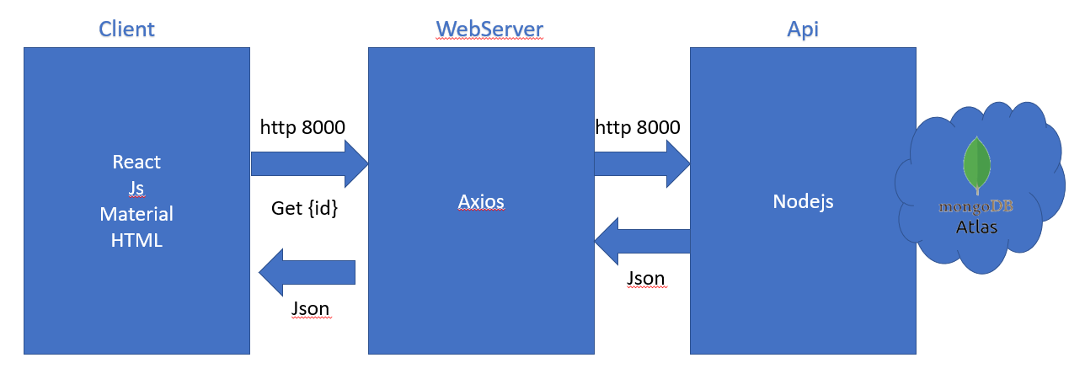

Uri Desing

|  |  |  |
| --- | --- | --- |
| **N°** | **Method** | **URI** |
| 1 | GET | [http://3.82.230.29.compute-1.amazonaws.com:3011/bike/{bikeId](http://3.82.230.29.compute-1.amazonaws.com:3011/bike/%7bbikeId)} |
| {bikeId} | id is an integer that is the primary key to get a bike |
|  | Return | {  "_id": {  "$oid": "62daf353ecaca364d35ba3d5"  },  "bikeId": 1,  "brand": "BMC",  "price": 200,  "category": "Sport"  } |

Compass

